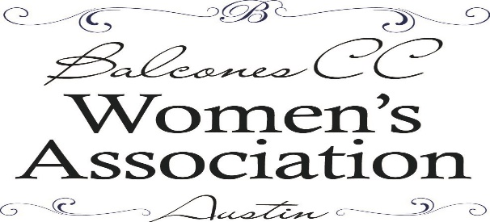
BCCWA Scholarship Foundation Silent Auction
Item Donation for 2019 Market Days
Friday, October 25th
Please include the following information about the donation you are providing. We look forward to your participation in our annual event!
Business Name: ______________________________________________________________
Contact Name: _______________________________________________________________
Phone: _______________________Email________________________________
Mailing Address: ____________________________________________________
Donation Item: ______________________________________________________
Value: $_____________________
Description: ________________________________________________________
Expiration and Limitations: ____________________________________________
Comments/Special Instructions: __________________________________________________________
______________________________________________________________________________
For more information, questions or if you wish someone to pick up your donation, please email us at bccwa.silentauction@gmail.com OR call Sylvia Johnson at 512.922-1971 to make arrangements.
Otherwise, please mail your donation to: Sylvia Johnson/BCCWASF
605 Girassol Cove
Cedar Park, TX 78613

You will receive a thank you for your generous contribution and, on request, a donation receipt for your tax return. Thank you for your support!

