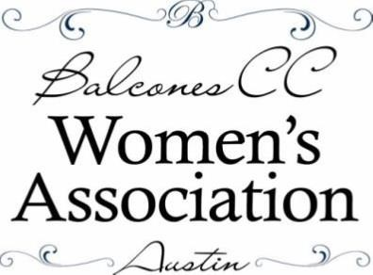
,

BCCWA SCHOLARSHIP FOUNDATION
MARKET DAYS / SILENT AUCTION
FRIDAY, OCTOBER 25TH

Dear Business Owner,

We are contacting you on behalf of the BCCWA Scholarship Foundation to request donation of an item or gift card for the Silent Auction in our annual Market Days event, our primary fundraiser for the scholarships we award each year to Round Rock ISD graduating seniors. With the help of businesses like yours, the Foundation was able to award $45,000 in scholarships to 15 students in the Class of 2019.

This year Market Days will be October 25-26, 2019 with our silent and live auctions on Friday evening. There are also vendor booths, raffle ticket sales and a pantry of homemade goodies throughout the 2-day event. More than 1000 people attend the event each year.

We hope you will join us this year in this worthy investment to further the education of area students. Your donation will be attractively displayed at the Silent Auction or with a color mini-poster of your logo for gift card donations. If your donation is received before September 1st, your business will be listed as a donor in our brochure which is given to all those who attend.

The BCCWA Scholarship Foundation is a 501(c)(3) non-profit organization, so your donation is tax deductible. On request, we will be happy to provide a letter with our tax number (80-0439559) acknowledging your donation.

If you can donate, please email us or mail it with the attached donation form to the address below. Let us know if you prefer to have us pick up your donation. All donations need to be received by October 1st. Feel free to contact me if you have any questions.

On behalf of the students, we thank you for your time and consideration.

Sincerely,

Sylvia Johnson | Please Mail Donations to:
BCCWA Market Days Auction Committee | Sylvia Johnson/BCCWASF
BCCWA.SilentAuction@gmail.com | 605 Girassol Cove
512-922-1971 | Cedar Park, TX 78613

